Prevention Skills Training: Cultural Competency
Participant Handout

Prevention Professionals will be exploring social determinants of health, multiculturalism, positionality, cultural competency, and implicit bias that contribute to cultural appropriate service delivery.

This Prevention Skills Training module focuses on the important considerations about what may influence our ability to provide culturally and linguistically appropriate prevention services.

AGENDA
- Cultural Competency
- Social Determinates of Health / Non-Medical Drivers of Health
- Bringing Cultural Competency in Action

LEARNING OBJECTIVES
Participants will be able to:
- Define Culture and Cultural Competency
- Identify the importance of intersectionality, positionality, culture, and the prevention field.
- Describe one action step you can take to help provide culturally and linguistically appropriate services.

ACTIVITY 1: What Lead You to Prevention?

- In your breakout rooms, select one person to be the reporter.
- Share with your group:
  - Why did you apply for the job you have today?
  - What led you to prevention work?​
  - Identify any commonalities.
- Come back to the main learning space and report out.

Identified Commonalities
1.
2.
3.

Cultural Competency

Cultural Competency
“Cultural competence is having the capacity to function effectively—individually and as an organization—within the context of the cultural beliefs, behaviors, and needs of a community or population group.” – U.S. Department of Health and Human Services

Intersectionality
Intersectionality considers the ways that multiple socially constructed identities create unique sets of experiences, which are qualitatively different than the sum of individual categories of identity.

ACTIVITY 2: Intersectionality & Prevention

- In your breakout rooms, select one person to be the reporter.
- Discuss with your group:
  - Why is the concept of intersectionality and this module on cultural competency relevant to your daily work?
- Come back to the main learning space and report out.

Relevancies Identified
1.
2.
3.

Positionality
Positionality refers to where one is in relation to their various social identities (gender, race, class, ethnicity, ability, geographical location etc.); the combination of these identities and their intersections shape how we understand and engage.

ACTIVITY 3: Your Cultural Pie

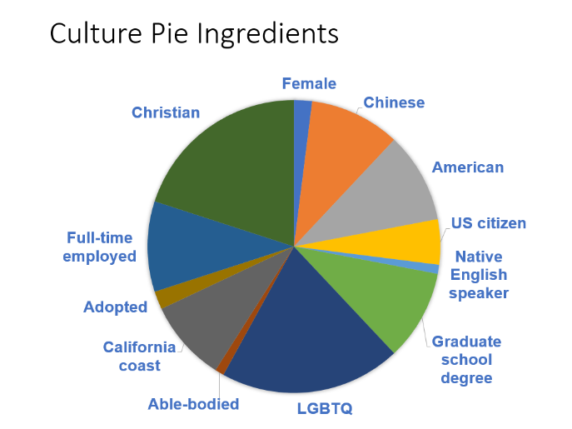
- Ask yourself:
  - What are some defining characteristics, practices, values that I hold?
  - How do I identify or define myself?
- Write down 5-10 aspects of your individual culture and identity.
- Draw your pie chart

Social Determinate of Health / Non-Medical Drivers of Health

Department of Health and Human Services Definition
“Social determinants of health are conditions in the environments in which people are born, live, learn, work, play, worship, and age that affect a wide range of health, functioning, and quality-of-life outcomes and risks… the patterns of social engagement and sense of security and well-being are also affected by where people live. Resources that enhance quality of life can have a significant influence on population health outcomes.”

World Health Organization Definition
“The social determinants of health are the conditions in which people are born, grow, live, work and age, including the health system. These circumstances are shaped by the distribution of money, power, and resources at global, national, and local levels.”

Spectrum of Mental, Emotional, and Behavioral Interventions
Fostering Healthy Mental, Emotional, and Behavioral Development in Children and Youth: A National Agenda examines the gap between current research and achievable national goals for the next ten years. This report identifies the complexities of childhood influences and highlights the need for a tailored approach when implementing new policies and practices. This report provides a framework for a cohesive, multidisciplinary national approach to improving MEB health.
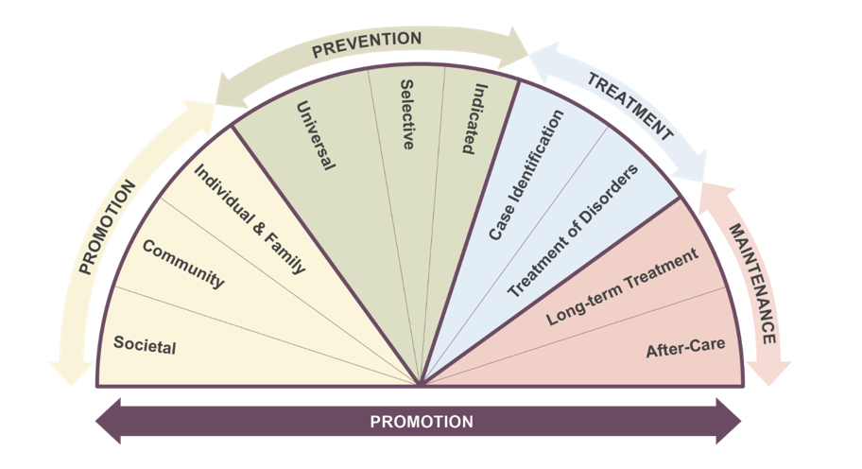
Bringing Cultural Competency into Action

Cultural Humility
“The approach of cultural humility goes beyond the concept of cultural competence to encourage individuals to identify their own biases and to acknowledge that those biases must be recognized. Cultural competence implies that one can function with a thorough knowledge of the mores and beliefs of another culture; cultural humility acknowledges that it is impossible to be adequately knowledgeable about cultures other than one's own.” Levi, Amy.
The Ethics of Nursing Student International Clinical Experiences” Journal of Obstetric, Gynecologic, and Neonatal Nursing. Vol. 38, No. 1, pp. 94-99 (2009).

Implicit Bias
Our Hidden Biases - The following video illustrates how our implicit biases can have implications for children. This video was developed by Project ABC, an Early Childhood System of Care Community, to spark dialogue among child-serving professionals. Even on our best days we may not be mindful of our thought processes and biases. And the decisions we make can have negative effects on our work and those we serve.

The National Standards for Culturally and Linguistically Appropriate Services in Health and Health Care (The National CLAS Standards)
CLAS standards aim to advance health equity by establishing a framework for organizations to serve the nation's increasingly diverse communities.
Enhanced National CLAS Standards

ADDITIONAL RESOURCES

- Tip 59: Improving Cultural Competence
- Children Youth & Families Self-Assessment Checklist
- LGBTQ Youth & Their Families Self-Assessment Checklist

